Readme file for Call diagonal spread using deep ITM-LEAPS
Colab address:
https://colab.research.google.com/drive/1GHkJ_6XhEgRFFOGKqW1zftftv45nOFOd?usp=sharing

Github address:
https://github.com/lgalico/WQU---Diagonal-Spread

The project uses the following libraries:
Os
Pandas
Matplotlib
Numpy
Scipy
Seaborn

The requirements for the program to run are to have all the libraries installed (using pip install [nameoflibrary] or just running the code with goggle colab) and having the DataSource.csv file loaded in the content file as shown below:

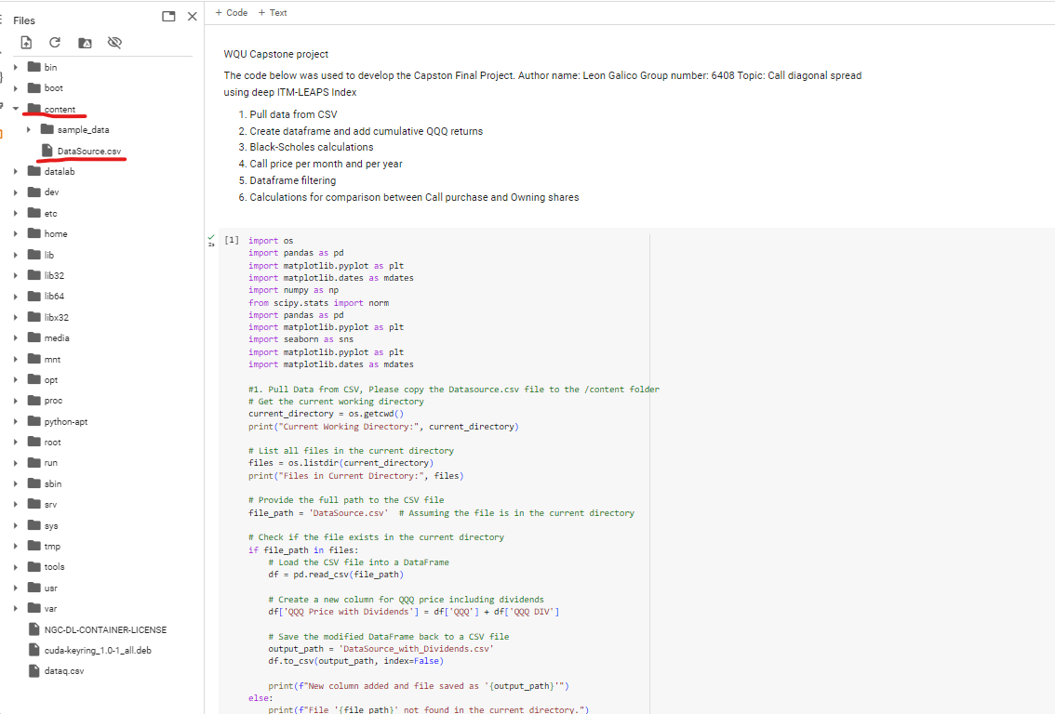
Since there are several programs to run this code it is impossible to explain how to pull the DataSource.CSV file into the program, if in google colab, it is only needed to upload the file from github in the Content directory.
The section that pulls the file is:
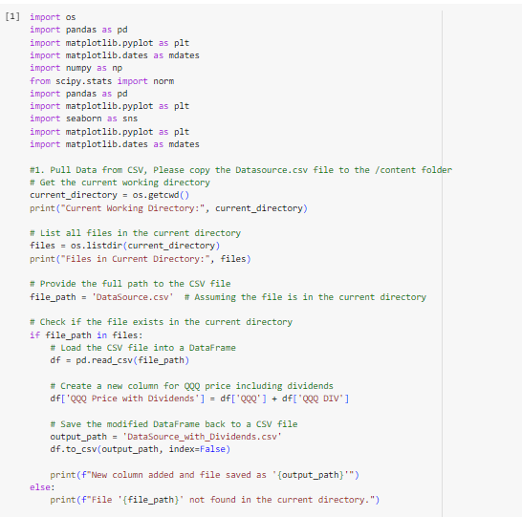
This section is commented thoroughly and someone with a little knowledge of Python can load the file DataSource.csv
Finally, there might be other configurations or programs to run the code, the file is loaded in the command
df= pd.read(file_path)
As long as the file is loaded in the file_path the code will run with no problem.

The link for google colab is:
https://colab.research.google.com/drive/1GHkJ_6XhEgRFFOGKqW1zftftv45nOFOd?usp=sharing

This book is allowed for anyone with the link.

Other option is to run from github but some programming experience is needed, specifically to load the DataSoruce.csv file
There is the excel file DataGenerate2.xlsm which contains the option scenario simulations, this file can be opened in Microsoft Excel and macros do not need to be active.

Files contained in Github
DataGenerate2.xlsm: Contain call simulation in excel
DataSource.csv: data source for the prices, interest rates, volatility and dividends of QQQ
LeonGalico_Capstone 07082024.ipynb: code for running in any python compiler, please upload the file DataSource.csv and load it to the program
WQU final paper.pdf: final paper

